JOB DESCRIPTION
Job Title | Internal Auditor | Location | Byblos Bank Syria  SA
Code: |  | Edition | 2
Division | General Management | Department | Audit Unit
Effective Date | August 2010 | Revised Date | August 2011
Employee Name |  | Starting Date

1- JOB PURPOSE
Maintain a professional, efficient and cost effective internal audit of the Branches, Units & Departments in Byblos Bank Syria.

2- LINES OF REPORTING
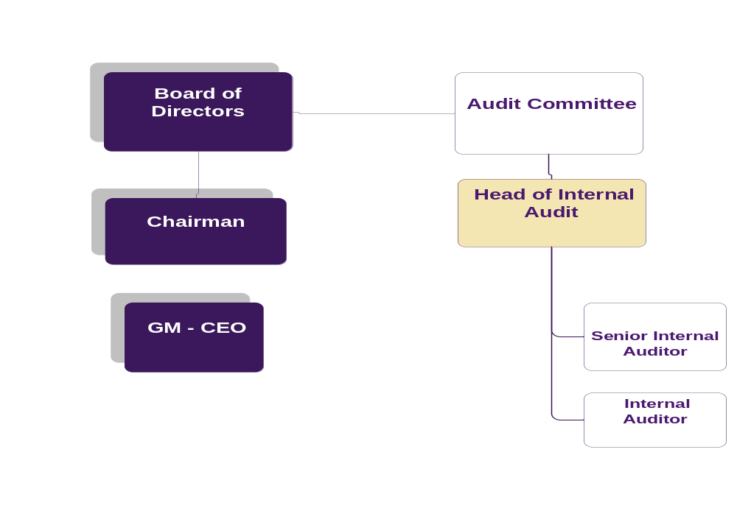

3- ORGANISATION RELATIONSHIP
Byblos Bank Syria :
- Head of internal audit
- Unit Managers
- Branch Managers

4- DUTIES & RESPONSIBILITIES
Preparing and Conducting Internal Audits Duties & Responsibilities

- Perform the audit work diligently, efficiently, and cost effectively.
- Adhere to the audit mandate planning in executing the audit and ensure that all the steps in the audit program are completed and updated when needed.
- Ensure that all audit work is complete and sufficient to satisfy the audit objectives.
- Review all the work of another internal auditor (assistant) working on the same engagement (if applicable).
- Promote the internal audit function throughout the bank by establishing and maintaining effective and professional working relationship with the bank’s employees and management.
- Maintain well documented and referenced files with proper support of evidence.

Providing Consulting Services Duties & Responsibilities

- Work with other internal auditors to identify common internal control weaknesses found on different audit mandates.
- Inform the Senior Auditor promptly of problems encountered.
- Escalate promptly to the head of Audit Department any problems of a technical, administrative and personnel nature that need action at the unit level.
- Communicate opportunities of productivity enhancement in the Bank's operations and bring forth new suggestions to the Head of department through the proper channels of communications within the audit department.

- Other Duties & Responsibilities as assigned.

5- JOB REQUIREMENTS
- Education Level:
- BA in business administration or in other related fields

- Experience :
- Minimum 3 years of banking experience of which 2 years in a branch, or
4 years experience in an accredited auditing firm in a similar position, or
3 years experience as a branch auditor with similar duties

- Required Competencies:

Technical
- Ability to produce assigned tasks in an accurate & timely manner (no error)( Quality Service)
- Ability to use the MS office as an intermediate(Computer Literacy)
- Proficiency in applying auditing standards and accounting principles; and the ability to perform the assigned audit procedures( Audit Skills) .
Behavioural
- Ability to express orally &/or in writing in a clear & concise way (Communication Skills)
- Ability to participate actively & positively within his/her own team & share relevant useful information (Team Work )
- Ability to recognize opportunities for improvement, remains positive & report difficulties (Self Management )
- Ability to demonstrate a willingness to adapt to changes at work & is open to do things in a new way (Flexibility & Adaptability)
- Ability to plan & priorities his/her own time & uses it effectively & efficiently in order to achieve long term goals( Time Management )

6- WORKING CONDITIONS:
- Environmental Conditions:
The job is largely desk based accordingly it does not require significant physical effort and does not expose the job holder to any significant environmental threats.

- Physical Conditions:
The job holder will work in a relatively high pressure environment that requires adherence to various deadlines and the ability to withstand stress.

7- MATERIALS USED
- Tools used in this occupation:
- Computer equipment (Laptops)
- Office
- Telephone
- Technology used in this occupation:
- Office suite software
- Spreadsheet software (e.g. Microsoft Excel)
- Word processing software (e.g. Microsoft Word)
- Presentation software (e.g. Microsoft PowerPoint)
- Electronic Mail Software (e.g. Microsoft Outlook)
- Internet
- ACL (Audit Command Language) Analysis tool
- Teammate (Electronic Documentation)
- Globus

I affirm having received, read and understood my Job Description.

Employee Name / Signature & Date

Direct Supervisor Name / Signature & Date

